Aim : Generate Histogram of Images, apply Histogram Equalization

Code :
import os
import cv2
import numpy as np
import matplotlib.pyplot as plt

script_dir = os.path.dirname(os.path.abspath(__file__))
image_path = os.path.join(script_dir, "4.jpg")
reference_path = os.path.join(script_dir, "3.jpg")

image = cv2.imread(image_path, cv2.IMREAD_GRAYSCALE)

if image is None:
print("Image not found")
else:
histogram = cv2.calcHist([image], [0], None, [256], [0, 256])

plt.figure(figsize=(8, 6))
plt.title("Original Histogram")
plt.xlabel("Pixel Value")
plt.ylabel("Frequency")
plt.plot(histogram)
plt.xlim([0, 256])
plt.grid(True)
plt.show()

equalized_image = cv2.equalizeHist(image)

plt.figure(figsize=(10, 5))

plt.subplot(1, 2, 1)
plt.title("Original Image")
plt.imshow(image, cmap="gray")
plt.axis("off")

plt.subplot(1, 2, 2)
plt.title("Equalized Image")
plt.imshow(equalized_image, cmap="gray")
plt.axis("off")

plt.tight_layout()
plt.show()

equalized_histogram = cv2.calcHist(
[equalized_image], [0], None, [256], [0, 256]
)

plt.figure(figsize=(8, 6))
plt.title("Equalized Histogram")
plt.xlabel("Pixel Value")
plt.ylabel("Frequency")
plt.plot(equalized_histogram)
plt.xlim([0, 256])
plt.grid(True)
plt.show()

reference = cv2.imread(reference_path, cv2.IMREAD_GRAYSCALE)

if reference is None:
print("Reference image not found")
else:
source_hist = cv2.calcHist(
[image], [0], None, [256], [0, 256]
)

reference_hist = cv2.calcHist(
[reference], [0], None, [256], [0, 256]
)

source_hist = source_hist / source_hist.sum()
reference_hist = reference_hist / reference_hist.sum()

source_cdf = source_hist.cumsum()
reference_cdf = reference_hist.cumsum()

mapping = np.interp(
source_cdf,
reference_cdf,
np.arange(256)
)

matched_image = mapping[image].astype(np.uint8)

plt.figure(figsize=(15, 5))

plt.subplot(1, 3, 1)
plt.title("Source Image")
plt.imshow(image, cmap="gray")
plt.axis("off")

plt.subplot(1, 3, 2)
plt.title("Reference Image")
plt.imshow(reference, cmap="gray")
plt.axis("off")

plt.subplot(1, 3, 3)
plt.title("Matched Image")
plt.imshow(matched_image, cmap="gray")
plt.axis("off")

plt.tight_layout()
plt.show()

Output :
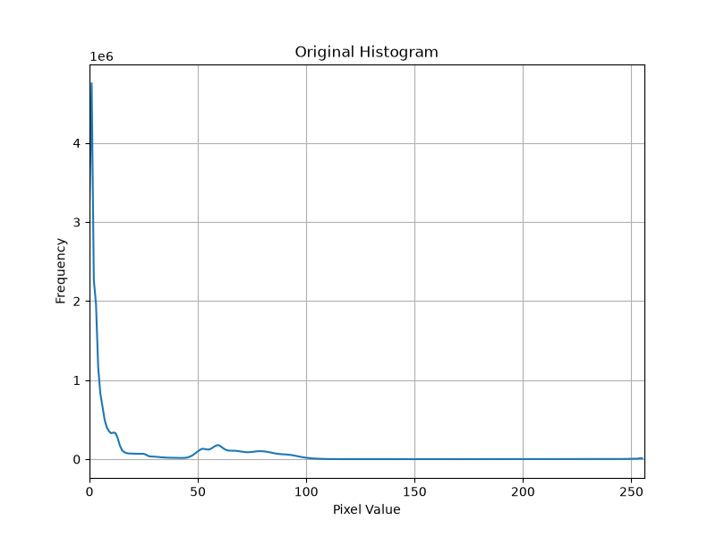

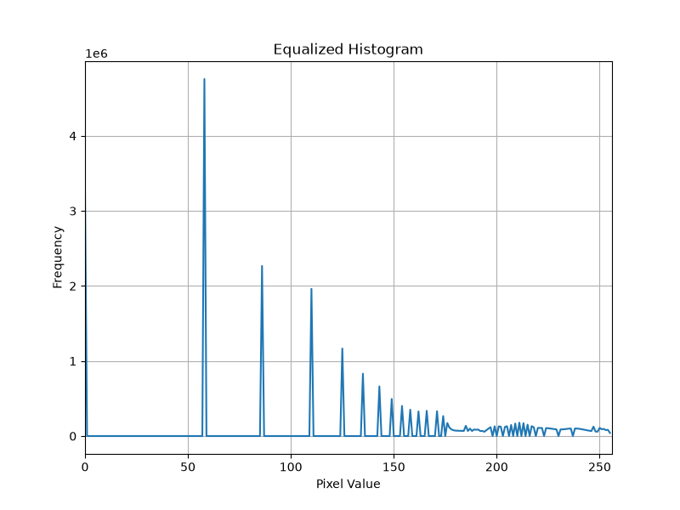

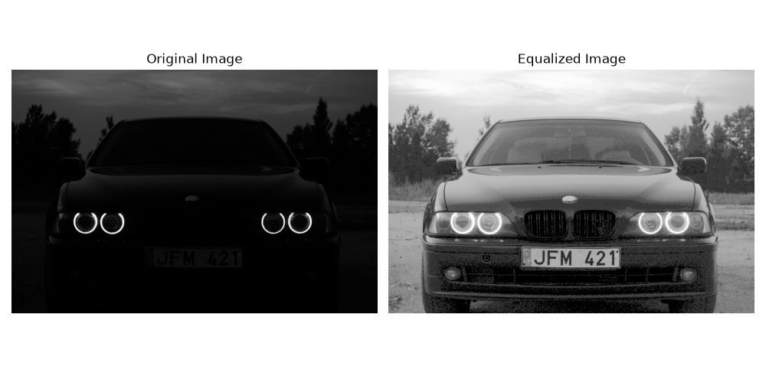
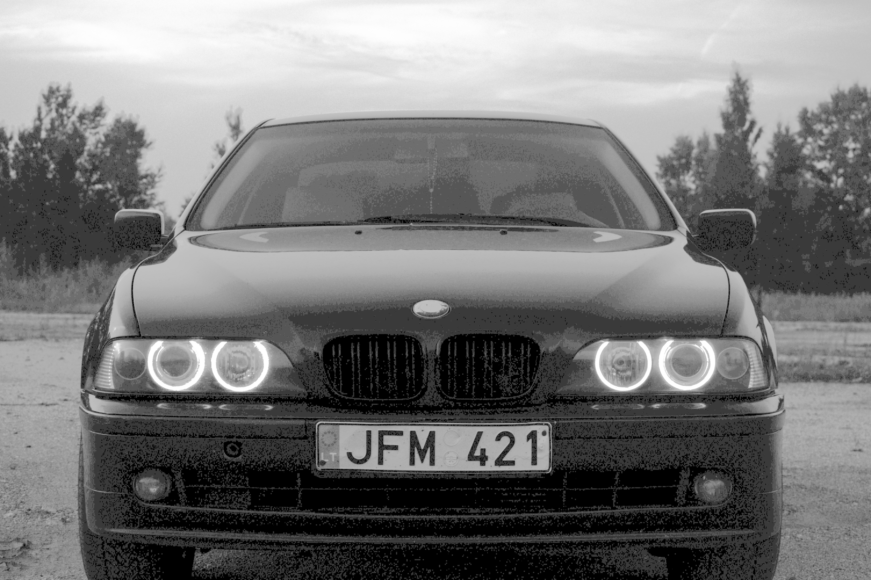

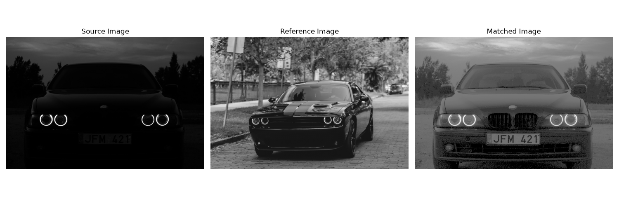

Original :
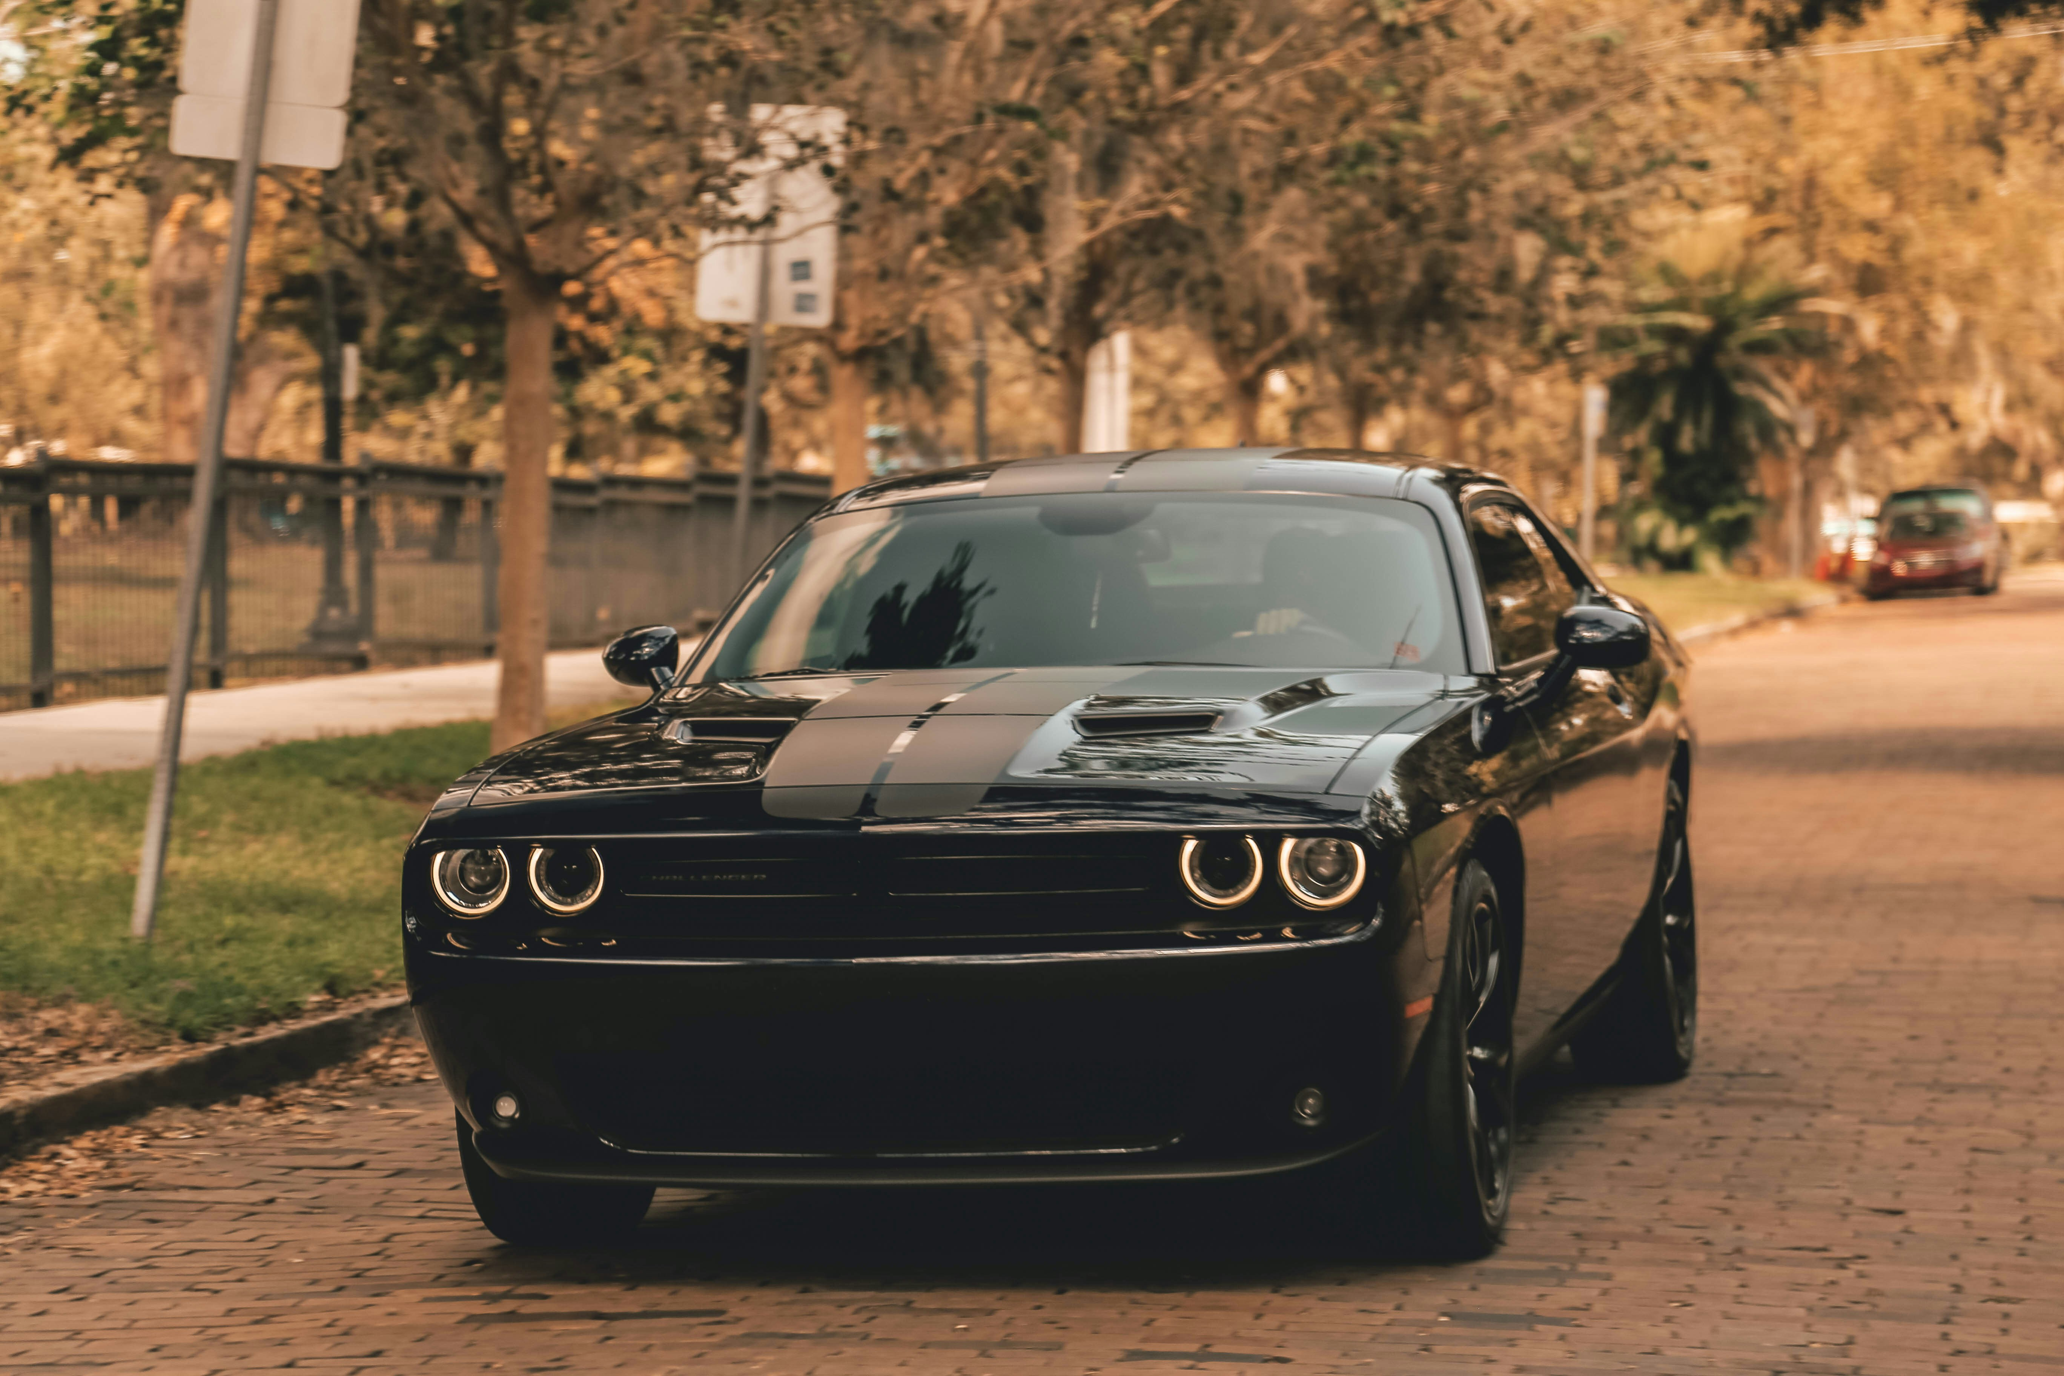

Refrance Image :
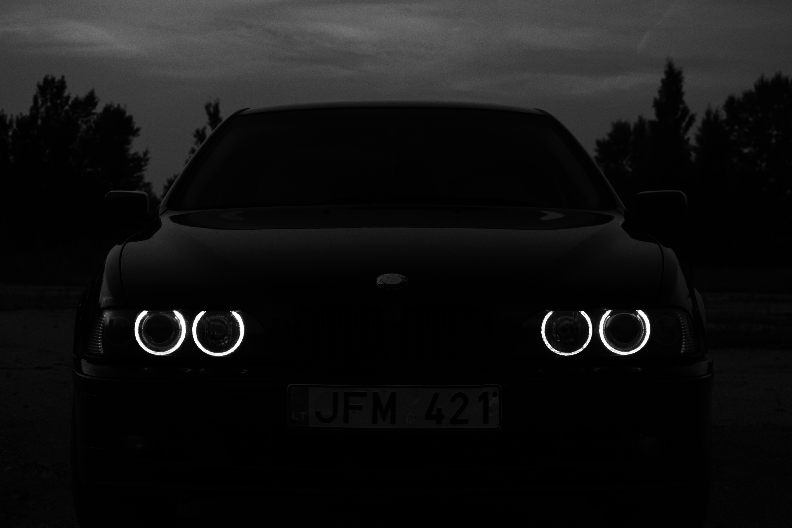

Conclusion :
This experiment helped us understand how histogram processing can be used to improve the quality and contrast of a grayscale image. Histogram equalization enhanced the image by spreading the pixel intensity values, making important details more visible. Histogram matching was also performed by using a reference image to adjust the intensity distribution of the source image. Overall, the experiment gave a practical understanding of how histograms can be used for image enhancement and improving visual appearance.

